Jevonte Frederick
6/17/2026
SNHU
Artifact One
For this artifact, I enhanced a project from a computer science course developing a compound interest calculator. The program was originally designed in C++ around a year ago, and I proposed rewriting it in Java. I also made some improvements to the program such as error handling for user inputs, which is a core part of the program. I chose this to display my capabilities in Java. C++ is one of my least used programming languages. I wanted to challenge myself to rewrite the program in Java. This artifact helped me refamiliarize myself with C++ by having to translate its code patterns and syntax in Java to closely match the original program design. I most importantly refactored redundant code from the original program. Though the program worked originally, it had redundant code and was able to be improved using coding best practices by creating methods to organize the overall design. This makes my translation into Java have cleaner code, which shows my foundation of coding best practices to improve program structure while maintaining functionality. This helps me display skills of organization and consistency by refactoring old code while translating it across programming languages.
From this artifact, I accomplished the outcome of demonstrating innovation in computing practices to deliver value. This is because of my ability to improve already useful banking application software. I made use of my best practices in coding as well to clean up previous work to reach more professional standards and demonstrate growth from my time in the Computer Science program. I also achieved designing and developing professional-quality oral, written, and visual communication. This is mainly because of the documentation of my code. A key part of professional communication and cooperation is documenting code so that stakeholders and collaborators can understand the program and data flow of software. This artifact shows my attention to clean code and using comments for documentation to walk through the code for readers of varied technical knowledge. With this as an example, I continue to build upon my communication skills by taking all potential audiences into account and making my software readable to key individuals. Furthermore, continuing to perform enhancements such as this on previous work would highlight my ability to make professional-level code out of past projects and promote myself in a future career of software development. Starting with smaller projects such as this to build on skills, I will be inspired to continue performing even greater enhancements to larger scales projects thanks to this experience.
The process of enhancing this artifact was straightforward. It takes time to rewrite the code since it cannot directly be copied and pasted from C++. Everything from method definitions to print statements had to be written with Java syntax. One of the challenges was getting java print formatting to match the formatting of my output from C++, but I managed to accomplish this. It also took work refactoring the user's input validation as separate methods as shown below:
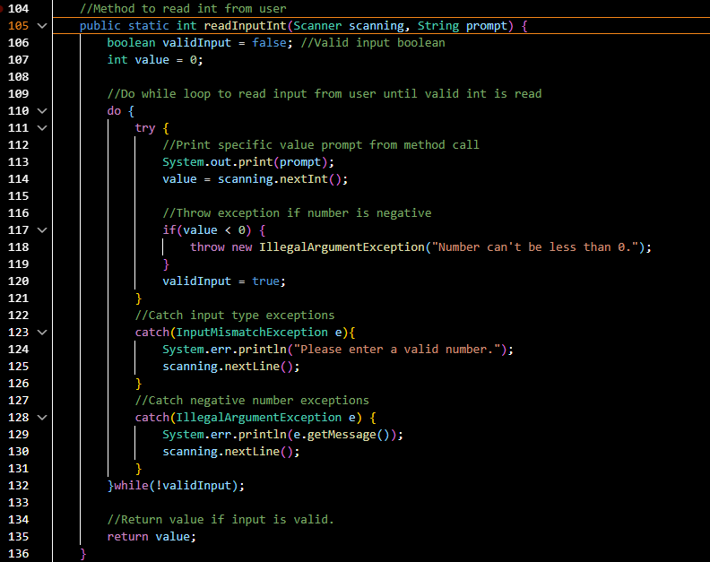
This is an example of a method I created to manage integer input in the enhancement. My original artifact used conditional loops for input handling. This refactoring makes the code more modular and cleaner having separate methods for input handling that are more readable. I also changed the printReport method to manage both reports, which removed the original design of separate methods for each. Here is a snippet of the enhanced code:
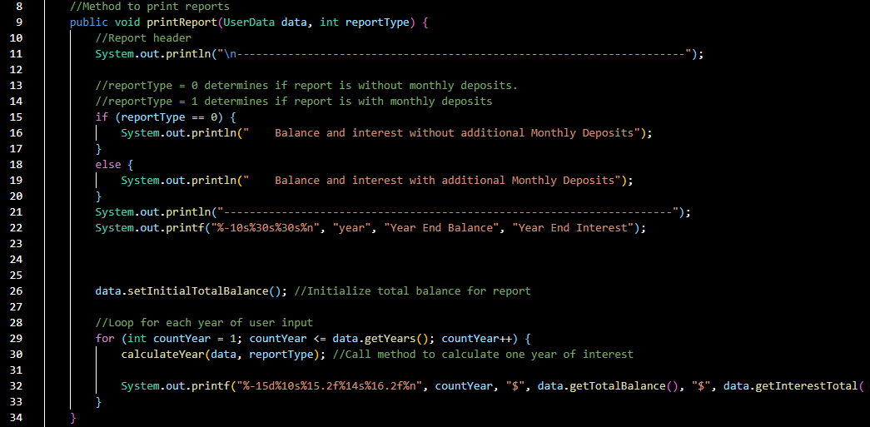
I enhanced the method to have a reportType variable that determines the type of report printed with or without monthly deposits, which removed a largely redundant method for each type of report. Improvements like this highlight my organization skills as converting the program from C++ to Java was not the only enhancement that can be done. The best practices I have learned and reinforced throughout the Computer Science program motivate me to organize my code and create truly professional software in all my projects. This also shows my consistency as the changes to the artifact beyond changing programming languages still produce similar output to the original artifact. This shows how I can adapt to different programming languages and maintain coding practices. Ultimately, this has helped me be more aware of the importance of refactoring code overall and understanding the differences in syntax between programming languages.

